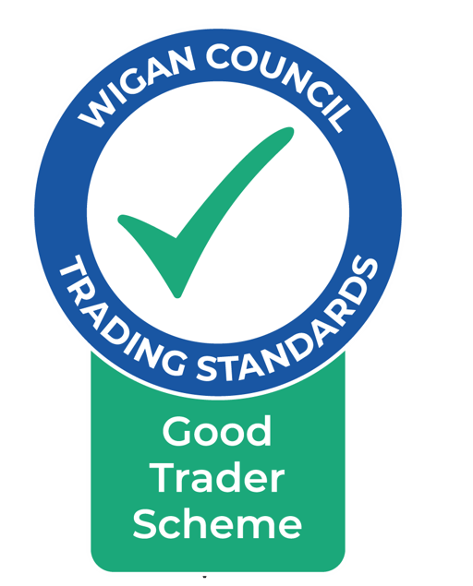
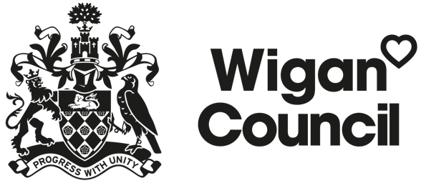

THE GOOD TRADER SCHEME

TERMS AND CONDITIONS

Businesses who satisfy the Scheme’s eligibility criteria, who can demonstrate a history of good trade practices and who agree to abide by the Scheme’s Terms and Conditions and Code of Practice, will be allowed on the Scheme. Membership of the Scheme is subject to ongoing compliance with its terms and conditions.

- Definitions

The “Scheme” refers to the scheme run by Wigan Council’s Trading Standards Service called the “Good Trader Scheme”.

The “Service” refers to Wigan Council’s Trading Standards Service.

“Member” means a business that is a member of the Good Trader Scheme.

“Business” refers to all sole traders, partnerships and limited companies.

“Service Manager” means the Manager of the Trading Standards Section for the time being of Wigan Council.

- Eligibility

- Membership of the Scheme is open to businesses which have a permanent address in the Borough of Wigan. Businesses which do not satisfy this criteria may be admitted on to the Scheme at the discretion of the Service.

- Businesses providing goods and/or services to consumers are eligible to apply for membership except businesses providing services listed in paras 2.a. and 2.b. below. Businesses providing the following services are not eligible for membership:
  - Financial services (except for credit unions as defined in the Credit Union Act 1979, who are mutual organisations and are authorised by the Prudential Regulation Authority and regulated by the Financial Conduct Authority); health care and related services; professional services,
  - Businesses providing any service exclusively or mainly to vulnerable adults or children.

- Applicants will provide the Service with full details of ownership of the business, its trading names, business premises and trade activities.

- Applicants must have been trading in their current format for at least 12 months.

- Applicants will state whether any county court judgements relating to any of their business activities, have been made against them or their business or any other person with responsibility for the operation of the business.

- Applicants will give details of any unspent criminal convictions relating to themselves, the business or any person with responsibility for the operation of the business. All Applicants will be judged on merit in relation to membership of the Scheme. Any such relevant person having an “unspent” conviction will not necessarily prevent the business from becoming a Member. This will depend on the relevance and circumstances relating to the offence.

- Where Applicants are a Member of any trade associations or claim to be endorsed by a private or public body, evidence of membership or endorsements must be provided on application.

- Applicants will have appropriate insurance in accordance with paragraph H below and will provide a copy of the certificate (s) to the Service before membership is approved.

- Applicants must provide 3 satisfactory references from recent customers of the business.

- On completion of the above, Applicants may be required to attend a pre-admission meeting with a Good Trader Administrator, lasting no more than 15 minutes, where an overview of the Scheme will be explained.

- Applications from businesses wishing to join the Scheme will be considered by an officer from the Service. The business’s trading history will be taken into account. The Applicant will be advised of the outcome of the application. Where an application is rejected, the Applicant will also be advised of the reasons for the decision. A fresh application will not be considered until after the expiry of 12 months from the date on which the notice rejecting the application was given to the Applicant.

- Businesses who have received a notice rejecting their application will have the right to appeal against the decision within 7 days of the date on which the notice of rejection was served on them. The appeal will be considered by the Service Manager whose decision will be final.

- The Service reserves the right to require documentation to be produced relating to the operation of the business and the qualifications of the employees, owners and Directors of that business.

- Admission onto the Scheme is at the discretion of the Service Manager.

- Fees and Charges

- The administration fee must be paid at the same time as the application is received. This fee is non refundable and is payable whether or not the application is successful.

- Where the administration fee is not received with the application form, the application will not be processed and the documents destroyed 14 days from the date of receipt of the application.

- On successful completion of the application process the Applicant will be deemed to have accepted the offer of membership only when the appropriate membership fee is paid to the Council within 30 days

- The membership year runs from 1st April each year and runs to the 31st March the following year. Members joining within that year will be required to pay the appropriate membership fees as a proportion of the yearly fee.

- Failure to pay the appropriate membership fee within the required time will be taken as rejection by the applicant of the offer of membership by the Service and the offer withdrawn.

- Where the Service withdraws the offer of membership for non payment of the membership fee, the applicant will be eligible to reapply for membership on payment of a further administration fee.

- Membership fees will be charged as a proportion of the full year’s fee from the 1st of the calendar month following the date of successful completion of the application process. This fee will be payable whether or not payment is made after the 1st of that month.

- Membership will automatically be renewed on the 1st April each year. Members who fail to pay the membership fee to the Service within the required time will have their membership terminated.

- Membership fees are non-refundable. In the event of membership being terminated or suspended by the Council or revoked by the Member, for whatever reason, the Member will not be entitled to a refund of either part or all of the Membership fees.

- Terms

- Applicants agree to be bound by these terms and conditions.

- In terms of the adherence of businesses to the Scheme’s Terms and Conditions, members will be held responsible for the actions of their employees and subcontractors working on behalf of their business.

- Members will be committed to trading fairly and acting in a polite, courteous and professional manner at all times.

- Members agree to comply with all legal requirements which apply to their business and the running of it.

- Where during the course of membership, members claim to be a member of any trade associations or claim to be endorsed by a private or public body, evidence of membership must be made available on request.

- Members are required to hold appropriate insurances in accordance with Paragraph H throughout the duration of their membership. The business is responsible for providing the authority with evidence of valid insurance on request.

- Members must inform the Service of any significant changes to the ownership/control of the business, or to its business address, name or phone number, within 14 days of such change.

- The Service must be notified within 14 days of any civil court judgements relating to the running of the business made against the owner (s) of the business (including any persons with responsibility for the operation of the business) or of any criminal prosecutions or cautions relating to such persons and/or business.

- Members must ensure that all employees are made aware of the Scheme, the Code of Practice and their legal obligations and that they are adequately trained for the work they carry out.

- When the Service is investigating a complaint or enquiry, Members will provide full information regarding their contract with the complainant/enquirer, if requested to do so.

- Members will either make available standard customer satisfaction questionnaires to each and every customer, or advise them that feedback can be left on the Good Trader Scheme website, whether or not the customer contacted the member via the Scheme. From time to time, the Service will review the nature and number of responses received to verify the integrity of the responses and assess the business’s compliance with the Scheme.

- Members, their families and associates must in no way interfere with the operation of the feedback system.

- Members will be awarded an average overall satisfaction rating based on feedback from their customers. The average results will be shown on the website.

- Customer comments recorded on the standard feedback form will also be recorded on the Scheme website and made available for prospective customers to see.

- In the event of an individual customer awarding a Member a 2 gold star or less overall rating and/or receiving an adverse comment, the member will be given the opportunity to comment, and have their response appended to the feedback.

- Members agree to comply with Terms and Conditions of the Scheme and to abide by the spirit as well as the letter of the Scheme, to trade fairly and to comply with the Code of Practice issued by the Service in connection with the Scheme

- If in any way the actions of a member or their employee, impose a risk to the reputation of the authority, the Scheme or its partners, the Service reserves the right to terminate the membership of the business.

- From time to time, if the Service deems it to be necessary the Service reserves the right to carry out audits of businesses to assess their compliance with the Scheme.

- Membership does not provide immunity from inspection, investigation, cautioning or prosecution for criminal offences or for action taken under The Enterprise Act 2002.

- Use Of The Good Trader Scheme Symbol

- On joining the Scheme, the Member will be issued with a membership number, and may be supplied with other literature advertising the Scheme. Members will be issued with a membership certificate and/or a copy of the Scheme symbol if requested.

- The symbol may be used:

  - For display purposes on business premises (including vehicles)
  - On business documentation
  - In advertising that business

- The symbol must be used in full, even when incorporated into other material.

- The words “ Trading Standards Approved”, “Trading Standards Approval”, or any other wording inferring approval by the Trading Standards Service or Wigan Council, must not be used in any way in conjunction with the symbol or with reference to membership of the Scheme. Contravention will result in termination of membership. A Member may also be guilty of a criminal offence.

- The Service retains the copyright and intellectual property rights in the Scheme, its certificate, symbol and all associated works. Members are given a licence for the duration of their membership of the Scheme to use the certificate and logo in the manner detailed in the Scheme.

- When membership ceases, for whatever reason, the business shall immediately stop using the symbol or referring to membership of the Scheme in any way either verbally or on any business documentation or advertising material and shall return the certificate and logo to the Service within 7 days.

- Termination/Suspension/Scheme Amendment

- The Service reserves the right to:

- Terminate any business’s membership of the Scheme at any time if it believes that:

    - the business or any of its employees have breached any term or condition of the Scheme,
    - the business or any of its employees have failed to comply with any clause of the Code of Practice,
    - it no longer satisfies the assessment criteria,
    - it has ceased trading, been made bankrupt or is in receivership
    - it has failed to pay the annual membership fee,
    - the business has a continuously poor satisfaction rating from its customers (2 gold stars or less), unless the business can provide a reasonable explanation,
    - the Member continuously receives no feedback, unless the Member can provide a reasonable explanation.

When considering whether to terminate a business’s membership, account may also be taken of information regarding the business activities received by our partners, officers of the Council, trade organisations and other government bodies.

The decision to terminate a business’s membership may be made jointly by officers of the Council and other organisations as deemed appropriate by the Service Manager.

- Publicise the termination of membership of the Scheme.

- The Service may suspend a business’s membership while assessing the circumstances of any of the above. If a decision is made to suspend membership then the business will be advised in writing. The effect of the suspension will be to remove the business from the Good Trader Scheme during the period of suspension. The period of suspension will depend on the circumstances. The business will be informed in writing of the outcome.

- The service may monitor the business activities of any member, as and when it is deemed necessary to do so. In these circumstances we will inform the business that it is being monitored and when the monitoring period has ceased. This may include contacting previous customers. Failure to co-operate with the monitoring may lead to suspension or termination of the membership.

- Where membership of the Scheme has been terminated the business will be advised in writing of the reasons for the decision and of the right of appeal against the decision. The appeal must be made in writing within seven days of when the notice of termination was served. The appellant will be entitled to appear and make representations to the Service Manager of the Trading Standards and Licensing Section. The appellant will be notified in writing of the outcome of the appeal within 7 days of the hearing of the appeal. The Service Manager’s decision is final.

- Where membership has been terminated, readmission on to the Scheme will not be considered until the expiry of 12 months since the termination date. Readmission is at the discretion of the Service Manager.

- Members may terminate their membership of the Scheme at any time. This must be done in writing to the Service. When the membership is terminated the provisions of paragraph E. 6 above shall take effect. The Member will not be entitled to any refund of any fees or charges.

- If ownership of the business changes, except for a change of partner or director, then the business shall inform the Service within 7 working days and membership of the Scheme will automatically be terminated. The business will be treated as a new applicant and the fees and charges and application procedures as laid down in Para B and C will apply.

- Where there is a change of partner or director then the business shall notify the Service of the change within 7 working days and the suitability of the business to remain on the Scheme will be reassessed. Depending on the circumstances, administration charges may apply.

- The Service reserves the right to:

      - amend the terms and conditions of the Scheme,
      - terminate the Scheme,
      - vary the fees charged (businesses will be given 30 days notice of variations in charges),
      - require further information and/or documentation to be produced by Members or Applicants,
      - require the business and its employees to produce evidence of CRB clearance where appropriate.

In the event of any of the above, the Service will notify Members of the amendments or of the termination of the Scheme.

- Complaints/Mediation Policy:

- Customers with complaints about Members will initially be referred to the Citizens Advice Consumer Service (CACS), the advice centre for the Service.

- If the matter is not resolved, CACS will forward the complaint to the Service, who will initially discuss the matter with the complainant and the business.

- If the complaint cannot be resolved, then the Member shall give written details of its position, within 7 days of a request from the Service. The Service may mediate if it considers appropriate.

- Where the Service mediates but no agreement can be reached then both the Member and the customer will be advised of alternative remedies.

- Liability To Customers:

- All Members of the Scheme are liable to their customers for any loss resulting from negligence or default of the business and its servants. The Service accepts no liability for any loss or damage which is claimed to have arisen out of any alleged act or failure to act on the part of any Scheme member.

- Members will maintain appropriate public liability insurance throughout membership of the Scheme with a minimum level of cover of 2 million pounds.

- Where applicable, Members will maintain appropriate employers’ liability covering a minimum of 5 million pounds throughout membership of the Scheme.

- Where applicable, Members will maintain appropriate professional indemnity insurance throughout membership of the Scheme.

Important - please read:
The Council holds personal data in accordance with the General Data Protection Regulations (GDPR). We hold your personal data as set out in our Data Primary Privacy Notice and the Good Trader Scheme Privacy Notice which can be viewed on the Council’s website www.wigan.gov.uk. If you would like any guidance please contact GDPRQueries@wigan.gov.uk

