
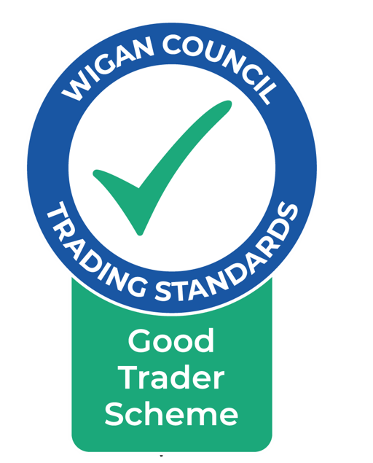

THE GOOD TRADER SCHEME
CODE OF PRACTICE

The Wigan “Good Trader Scheme” is a list of businesses, available on a website, that the public can use to find a reputable supplier of goods or services. The businesses are usually based in the Wigan and Leigh areas, have a good trading record and have agreed to follow the rules in the following Good Trader Scheme Code of Practice.

Businesses are rated by their customers who can leave feedback on the website. The public can then see how others have rated them by looking at the number of gold stars they have been awarded (1 star = very poor, 5 stars = very good) and the comments made.

- Definitions

The “Scheme” refers to the scheme run by Wigan Council’s Trading Standards Service called “The Good Trader Scheme”.

The “Service” means the Wigan Council Trading Standards Service.

“Member” means a business who is a member of the Good Trader Scheme.

- Trading Standards Commitments

- The Service will administer and monitor the Scheme.

- The Service will publish and promote a list of Scheme Members and their contact details.

- The Service will maintain a business directory on a website.

- Whilst the Service will provide advice and information on civil and criminal law to Members on request, it is the responsibility of the Member to ensure that they are aware of and compliant with, the law.

- The Service will provide reasonable assistance with the training of staff in relation to Trading Standards law.

- Any consumer complaint received by the Service regarding work done by a member company will be passed to the Citizens Advice Consumer Service (a National Consumer Helpline) in the first instance. They will then refer any matter back to the Service or any other appropriate body, if they decide the consumer needs more advice. Where appropriate, the Service will mediate.

- Where the Service mediates but no agreement can be reached, the Member and the customer will be advised of the various alternative remedies.

- The Service will monitor complaints made against Members.

- The Service will monitor the number of responses and the feedback received about Members from their customers. We ask for customers’ details so that we can verify the information they give us, if necessary. Their details will not be given to any other body or person. If a customer’s details are not provided, the feedback will not be used.

- If an adverse comment or feedback report is received (ie 2 gold stars or less) from a customer, the Service will discuss the matter with the complainant to verify their details. If correct, then the Service, with the permission of the customer, will contact the Member and discuss the problem. If the matter is resolved, the customer will be asked to re-evaluate their feedback. If the customer doesn’t want the Service to contact the Member, or if after consultation with the business, the customer is unhappy with the outcome, then the feedback will be published as it stands, providing the comment complies with the law.

Members Commitments

- Members will fully comply with all relevant consumer law and will trade fairly within the spirit of the law. If the Member is in doubt about which consumer laws are relevant, the Service can be contacted for information and advice.

- Members will follow the General Codes, Standards and Guidance issued by any relevant government Department or Office.

- Where a service is being provided, Members will provide their customers with a quote, estimate or, where applicable, a price list detailing the work to be carried out, inclusive of VAT. This will be in writing unless the circumstances are exceptional. Where applicable, members must provide customers with a written schedule of works and a written quotation, inclusive of VAT, before any work begins. Any changes made to this schedule during the period of the contract, shall be communicated to the customer in writing before any further work is carried out.

- Any call out charges or minimum charges must be given to the customer in advance.

- Members will provide customers with an invoice or receipt. This must show the items supplied and, where applicable, the work carried out, including items supplied, labour and any other costs and these business documents must state the Member’s name and business address.

- Where parts have been replaced, customers must be given the chance to examine and keep them.

- Members will not use second hand or re-conditioned parts unless agreed by the customer before the work is begun.

- Members will not refer customers on to other businesses whether they are members of the Scheme or not.

- Members must either provide feedback questionnaires to their customers or inform customers that feedback can be left on the Good Trader Scheme website.

- Members will co-operate with any reasonable request for information received from the Service and will provide such information in a timely manner.

- Members will ensure that appropriate identification and contact methods are used when visiting or delivering goods to customers in their own homes.

- Members will not seek to take advantage of vulnerable consumers, will not “cold call” potential customers and will not engage in high pressure sales techniques.

- Members will ensure that where appointments are made with customers, as far as is reasonably possible, those appointments should be kept. If for any reason it can’t be kept, the customer should be informed as soon as possible. Under no circumstances should any member call on customers unannounced.

- Guarantees and warranties

  - where standard guarantees/warranties are offered to customers, clear and accurate details must be provided to the customer.

  - where additional guarantees and warranties are offered to consumers, it will be made clear that these are optional.

- Members will ensure that all employees are made aware of The Code of Practice and the Scheme’s Terms and Conditions.

- Members will act in a polite, courteous and professional manner at all times.

- Where works are carried out in a customer’s home, Members will complete all work and leave the site in a neat and tidy state.

- At all times the Members of the Scheme will retain all contractual and statutory liability to their customers in connection with the supply of services and goods. In administering the Scheme the Service accepts no such liability.

- The Service acts as a collator of public information about businesses. The information provided is accurate to the best of our knowledge and belief. However, this information must not be taken in any way as a warranty by the Service of the status of any individual business, partnership or limited company. The Service will not accept liability for loss or damage arising out of the use of information obtained under the Scheme.

